Int. J. Environ. Res. Public Health 2009, 6, 492-525; doi:10.3390/ijerph6020492

Emerging Patient-Driven Health Care Models: An Examination of Health Social Networks, Consumer Personalized Medicine and Quantified Self-Tracking

Published article: http://www.mdpi.com/1660-4601/6/2/492/ - Melanie Swan, Research Associate, MS Futures Group, Palo Alto, CA 94306 USA, 415-505-4426, m@melanieswan.com

The empowered self: a new model of health and health care
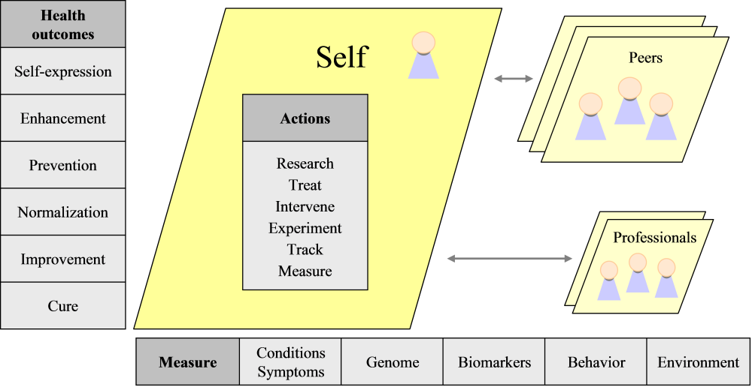

Key findings:

What is changing the health ecosystem the most right now?
- In addition to genomic medicine, patient-driven health care models may be one of the most important factors shaping the health ecosystem at present and in the near future

Patient-driven health care models are novel and valuable resources
- A growing variety of patient-driven health care models are emerging to supplement and provide solutions where traditional health services are unable, some of these models include health social networks, consumer personalized medicine and quantified self-tracking communities

Long-tail medicine: possible solutions to the other 80% of health issues?
- Individuals acting independently or through health social networks and personalized medicine and quantified self-tracking communities could significantly expand health research as they focus on the long tail of medicine, having the time, interest and utility to concentrate on health issues of personal or affinity community relevance, especially pharmaceutically-uninteresting or complex conditions that are underserved by traditional medicine

Health care is now more open and collaborative, and holistic
- The definition of health and health care is changing to include an increased level of information flow, transparency, customization, collaboration and patient choice and responsibility-taking, as well as quantitative, predictive and preventive aspects. A more systemic approach is acknowledged to be necessary, incorporating genes, biomarkers, environment, lifestyle and other factors, and by considering collection of conditions together

Health means wellness enhancement and exploration not just cure
- As shown in the image above, there are more desired health outcomes at different levels: the initial focus on illness cure is broadened to include the improvement or resolution of chronic ailments, the attainment of baseline health normalization, the prevention of unhealthy states and promotion of wellness, the enhancement of current genetic, physical and mental health and the notion of health possibly being a vehicle for creative self-expression

Peer support and health information sharing is invaluable; physicians as partners
- Individual consumers are taking a much more active role in their care, independently, in collaboration with health peers, and in consultative co-care, rather than paternalistic relationships, with physicians and other medical professionals. Finding others in similar health situations with whom to share information about conditions, symptoms and treatments can be a tremendous resource

More employer health rebate programs to provide a cash incentive for healthy behavior?
- Financial incentives from employers and insurance companies could have the most success in shifting health-related behavior, for example Safeway decreased health costs 13% through an $800/year rebate to healthy employees or employees who improved their health. Health social networks could provide positive-impact peer pressure, for example, having members compete on an opt-in basis to lower key biomarker scores like cholesterol and blood pressure, using third-party tests from LabCorp to validate the results

Health social networks to run more of their own clinical trials?
- Individuals and peer-groups such as health social networks could emerge as important players in the new health ecosystem, wielding market power through aggregated buying groups, conducting self-run clinical trials as an alternative to pharma-run clinical trials, offering novel services such as on-demand physician consultation, serving as an indicator of market demand for medical research and possibly leading translational medicine efforts

